Topologies & cloud computing
Y13 - Cambridge International 9618 | 2.1.3 - 2.1.4 | Student booklet
Name: _______________________________ | Date: _____________

This booklet has everything you need for the lesson in one place. Work through it in order:
- Learn sections show the key slides. Read them carefully - they explain the ideas and show worked examples.
- Task sections are where you practise. Each task uses what the slides just before it taught you.
- Tasks get harder as you go and use real Cambridge 9618 Paper 1 questions. Task 6 is an extension.
Do Task 1 from memory before you turn the page - it checks what you remember from the online lesson.
Task 1 Recall test - last lesson [20 marks]
Closed book. 10 minutes. These questions are on the online lesson: LANs and WANs, client-server and peer-to-peer, thin and thick clients.
1 Write LAN, MAN, WAN or PAN next to each description. [4]
Description | Network type
Connects the devices in one building or site, such as a school
Covers a city, such as a university campus spread across several buildings
Covers a country or the world, such as a bank's network of cash machines
Centred on one person, with a range of a few metres

2 Give three benefits of networking computers rather than using stand-alone computers. [3]

3 Tick one box in each row to show whether the statement describes the client-server model or the peer-to-peer model. [5]
Statement | Client-server | Peer-to-peer
Files are stored on a central server
Each node stores its own files and can share them with other nodes
User IDs, passwords and access rights are managed centrally
Best suited to a small network of about ten or fewer nodes
Data is backed up centrally, so it is more secure and stable

4 A bank's online banking system uses the client-server model. Identify the client and the server in this system, and describe the role of each. [4]
Based on 9618/11 May/June 2024 Q5(a).

5 Examiners mark exam scripts online using thin-client software. Describe two characteristics of a thin client, and explain how each one applies to this marking software. [4]
Based on 9618/12 May/June 2024 Q3(b).

Learn Network topologies
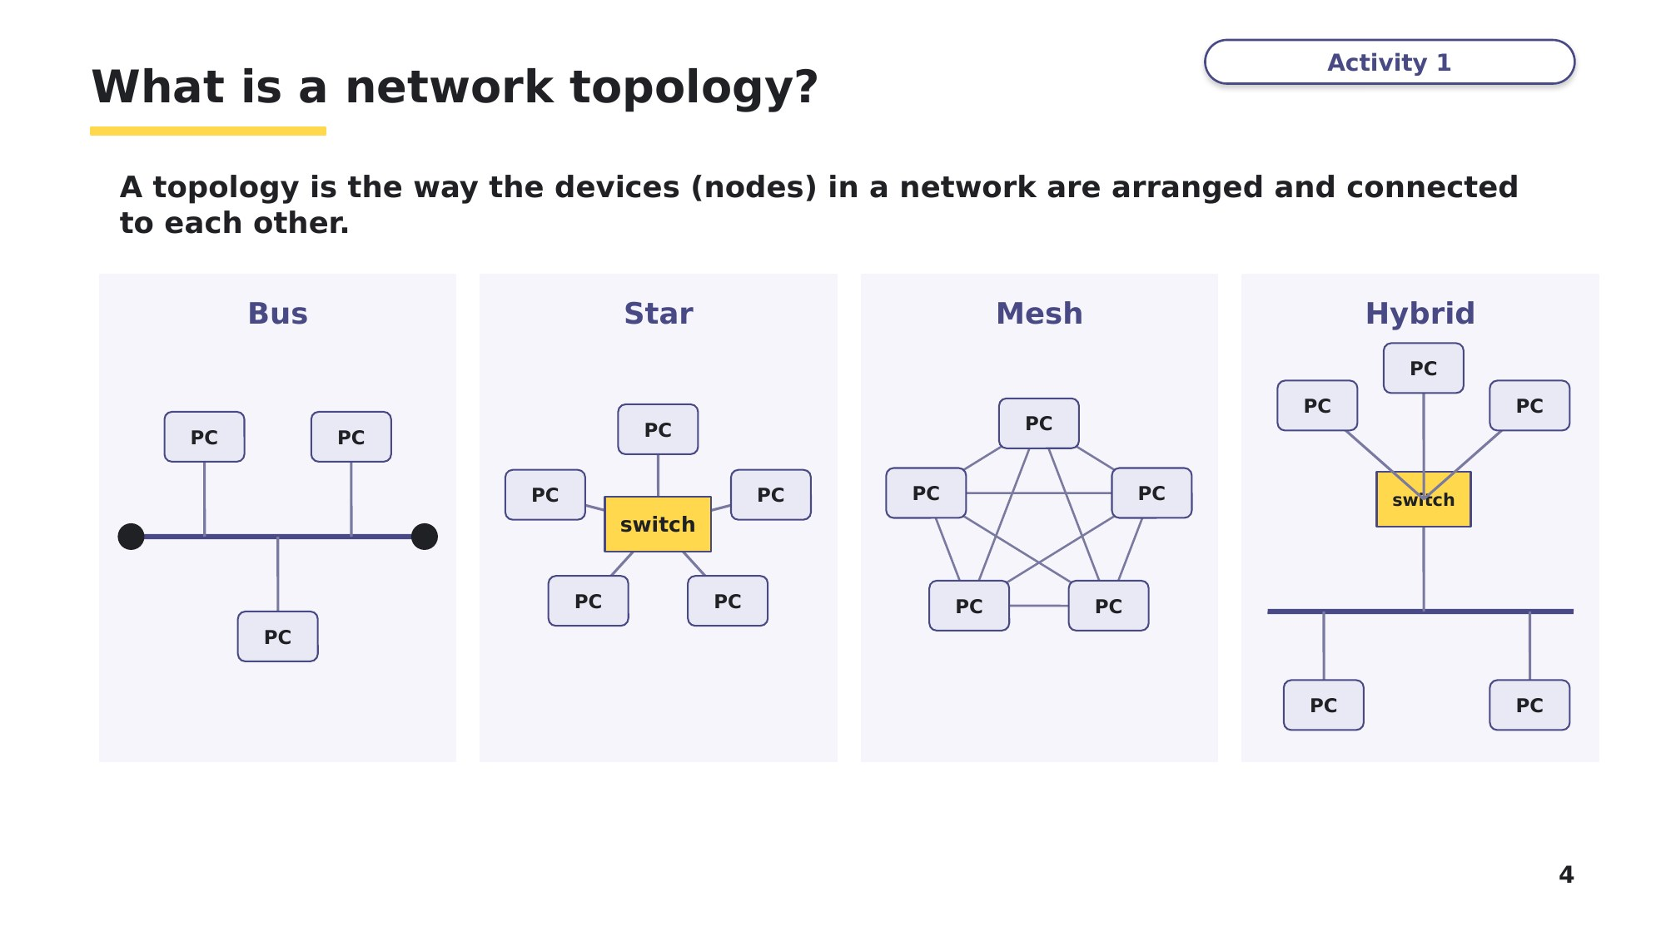
Slide 4 - What is a network topology?
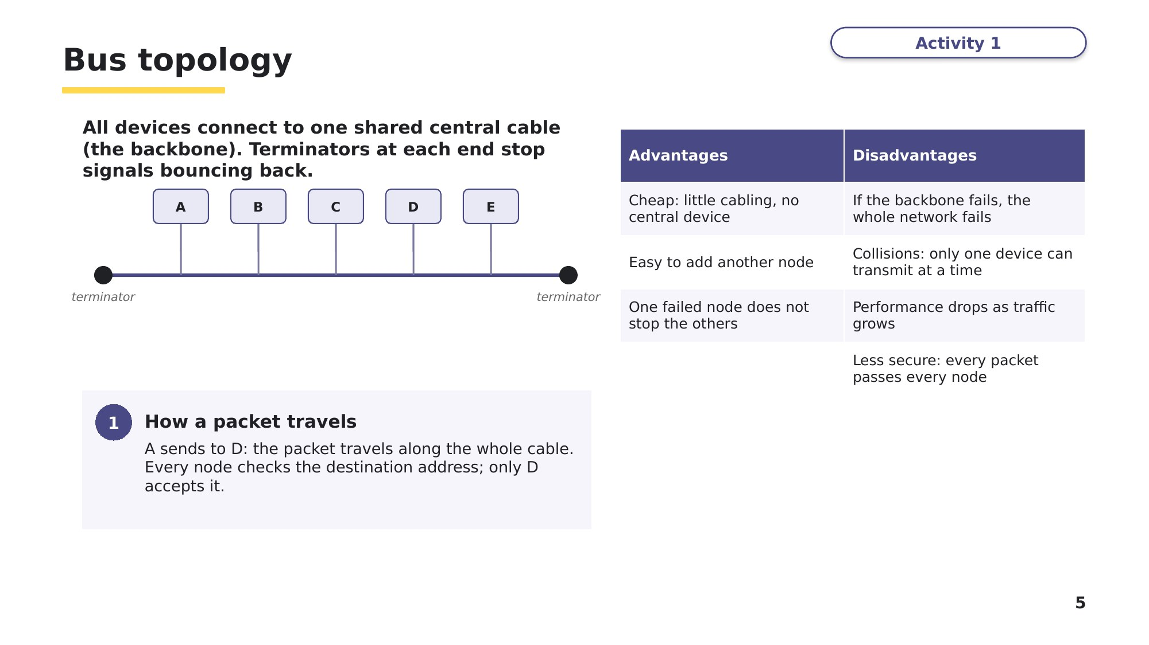
Slide 5 - Bus topology
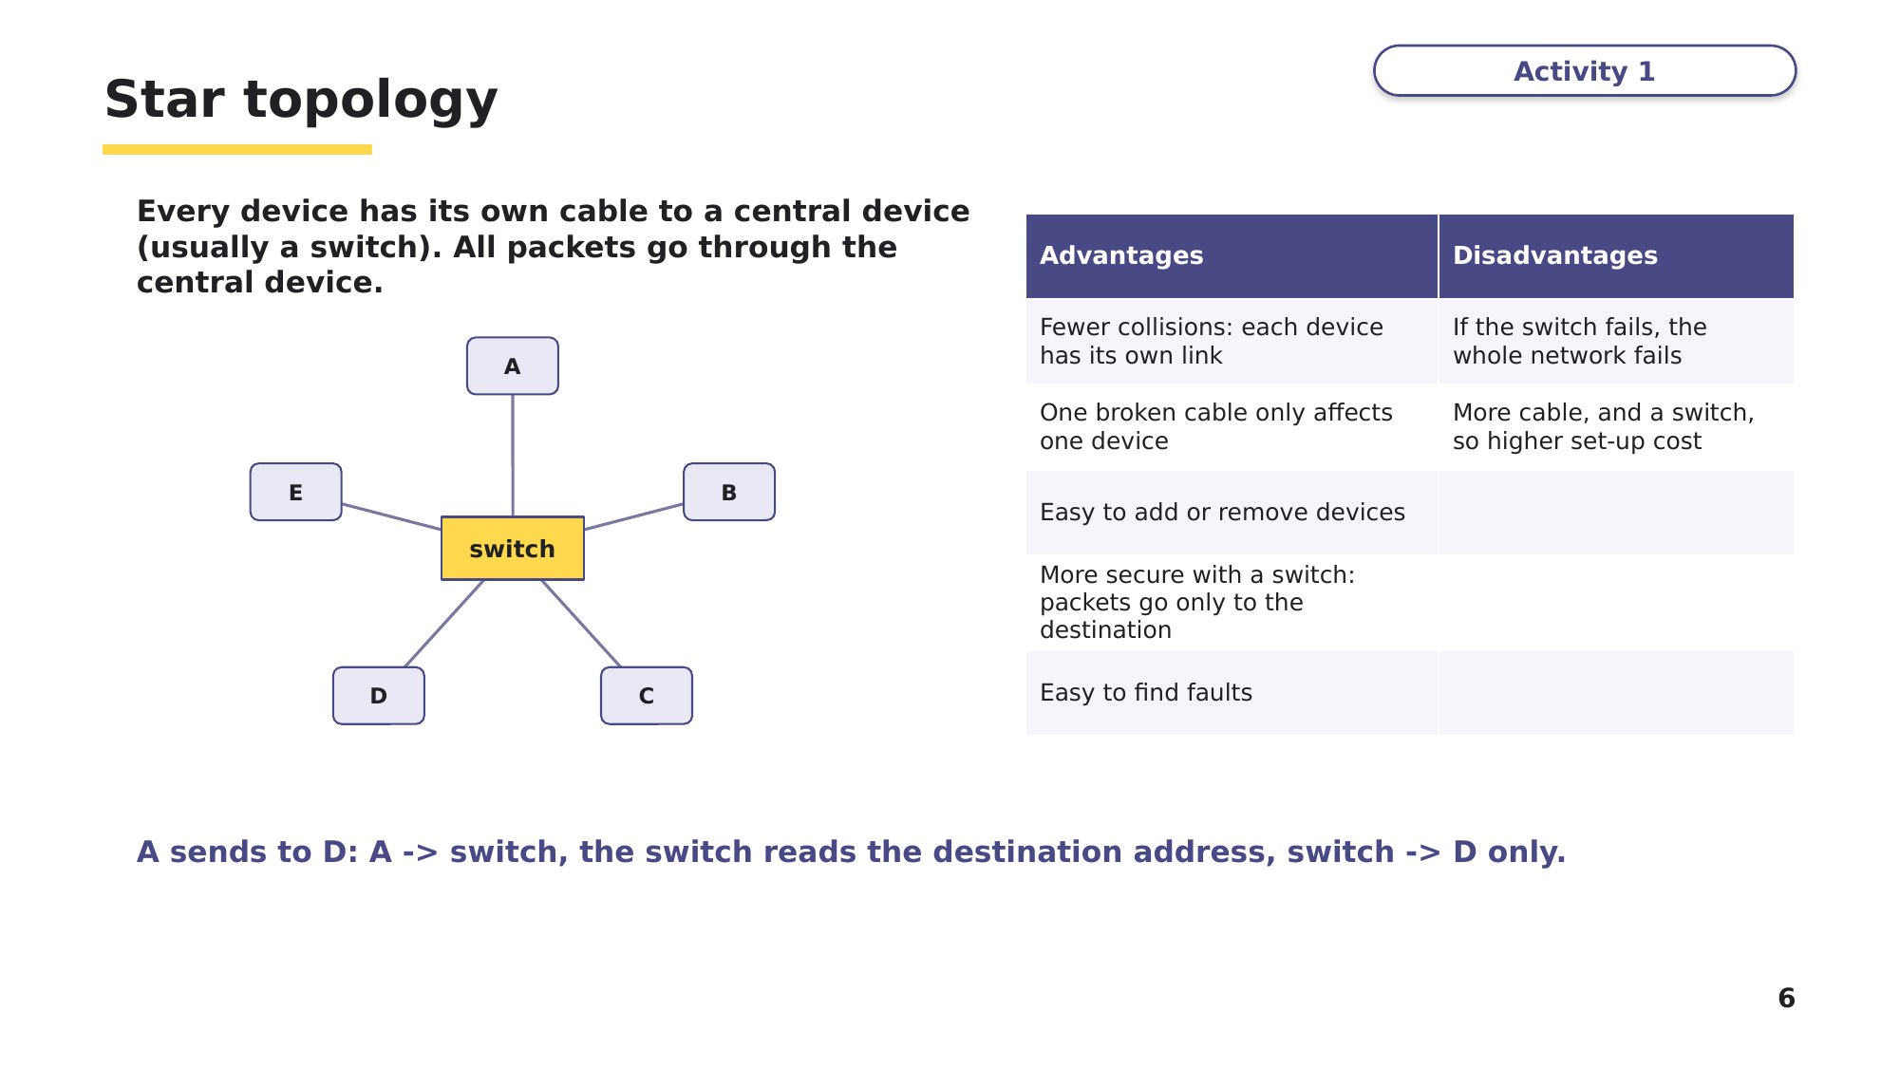
Slide 6 - Star topology
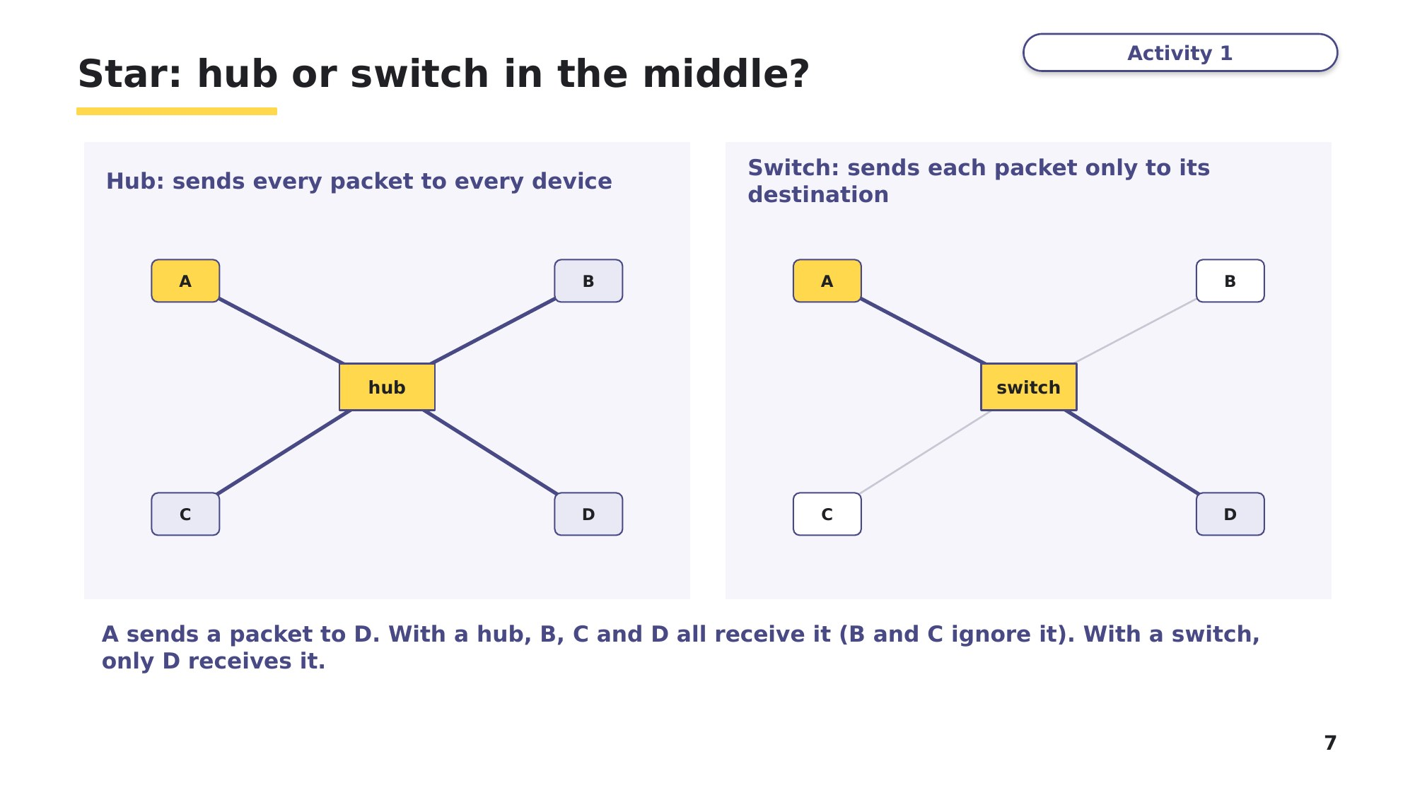
Slide 7 - Star: hub or switch in the middle?
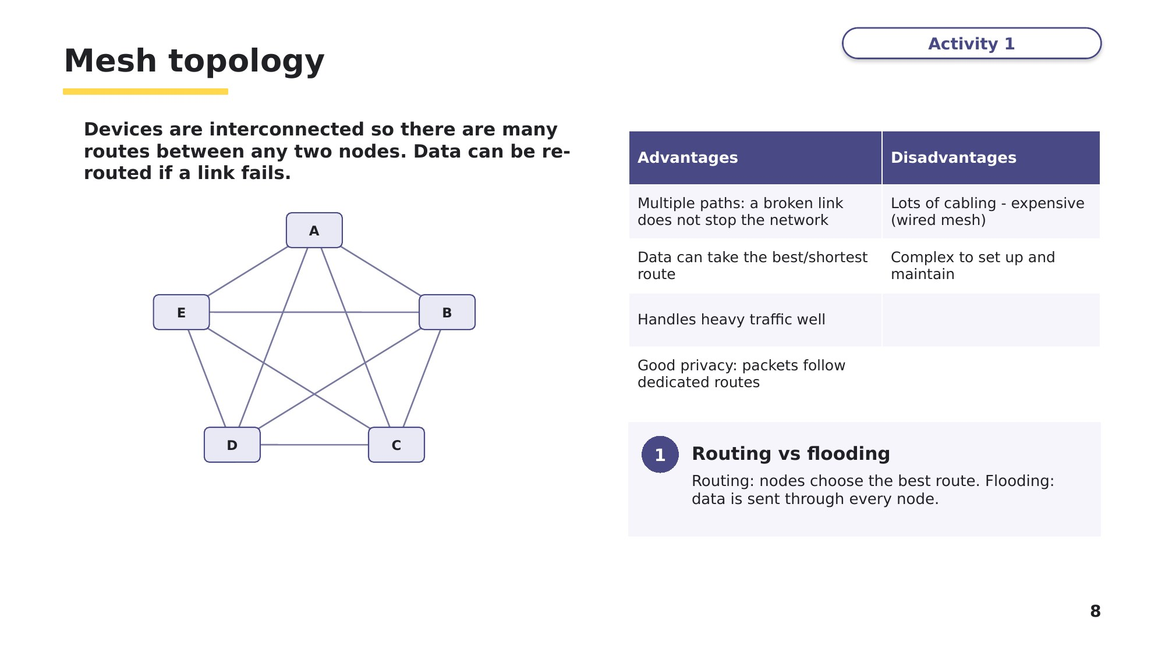
Slide 8 - Mesh topology
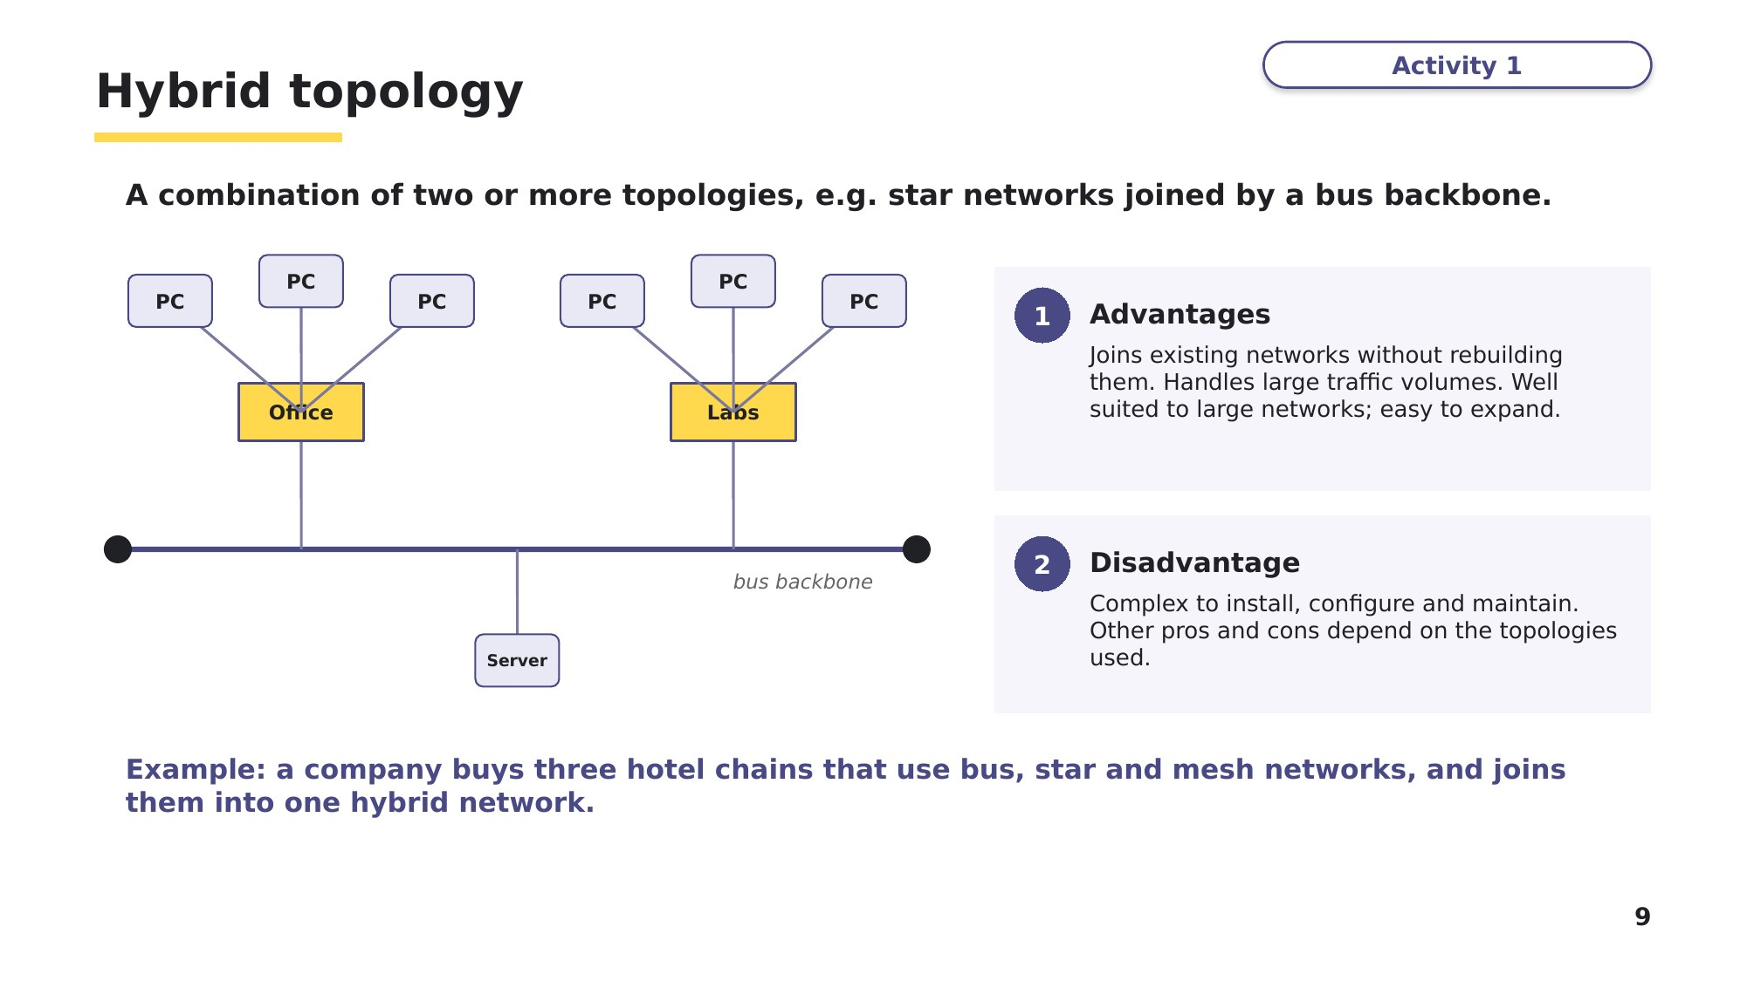
Slide 9 - Hybrid topology

Task 2 Draw and identify topologies [8 marks]
(a) Draw a star network that has a switch, four computers and a printer. [2]

(b) Draw a bus network that has four computers. Label the terminators. [2]

(c) Name the topology that each statement describes. [4]
Statement | Topology
If the single central cable is cut, no device can communicate
There are several different routes between any two devices
Each device has its own cable to a switch
Three star networks are joined together by a backbone cable
Task 3 Tick the topology, then trace a packet [8 marks]
(a) Tick one or more boxes in each row to identify the topology, or topologies, that each statement describes. [5]
Based on 9618/11 May/June 2024 Q8(a).
Statement | Bus | Star | Mesh
All devices connect to one central device
All devices connect to a central cable
There are multiple paths for the packets to travel
Robust against damage: if any line fails, the rest of the network keeps full functionality
Most likely to lose data through collisions

(b) Computer A sends a packet to computer D. The network also contains computers B, C and E. For each network, list every computer, other than A, that receives the packet, and say which one accepts it. [3]
Network | Computers that receive the packet | Computer that accepts it
Bus
Star with a hub
Star with a switch
Learn Summary: comparing the topologies
Use this table to check your Task 3 answers, then keep it for revision.
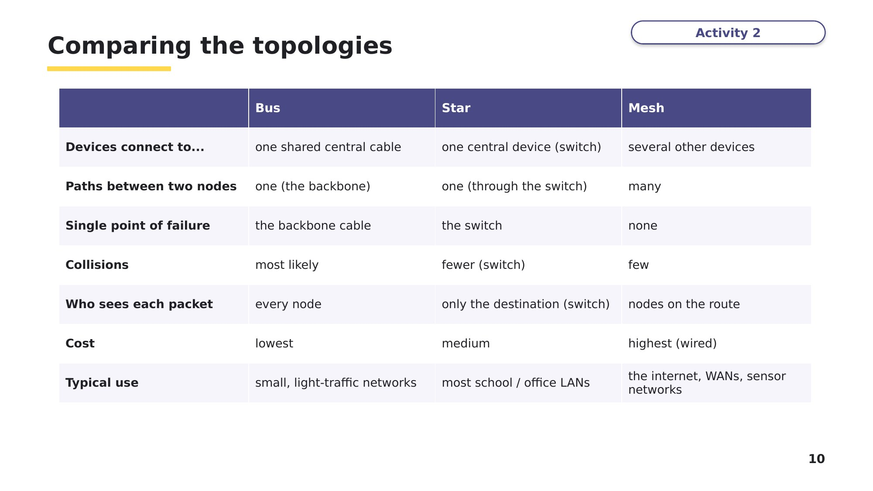
Slide 10 - Comparing the topologies
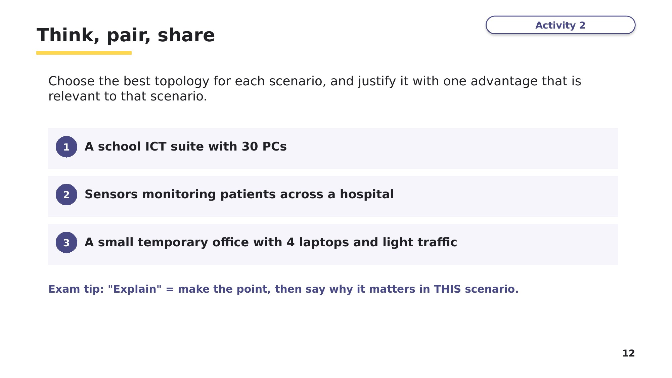
Slide 12 - Think, pair, share
Discuss the three scenarios with a partner before you start Task 4.
Task 4 Exam questions: topologies [8 marks]
(a) A new classroom is being set up with 20 computers and a switch. Explain one advantage of using a star topology instead of a bus topology in this classroom. [2]
9618/11 October/November 2023 Q2(d).

(b) Explain how packets are transmitted between two devices in a star topology. [2]
9618/13 May/June 2024 Q5(b).

(c) Give one advantage and one disadvantage of a mesh topology. [2]

(d) A company takes over three hotel chains. One uses a bus network, one a star network and one a mesh network. Explain why the company might connect them as a hybrid network. [2]

Learn Check your Task 4 answers
Only look at this slide once you have finished Task 4. Mark (a) and (b) against the official marking points.
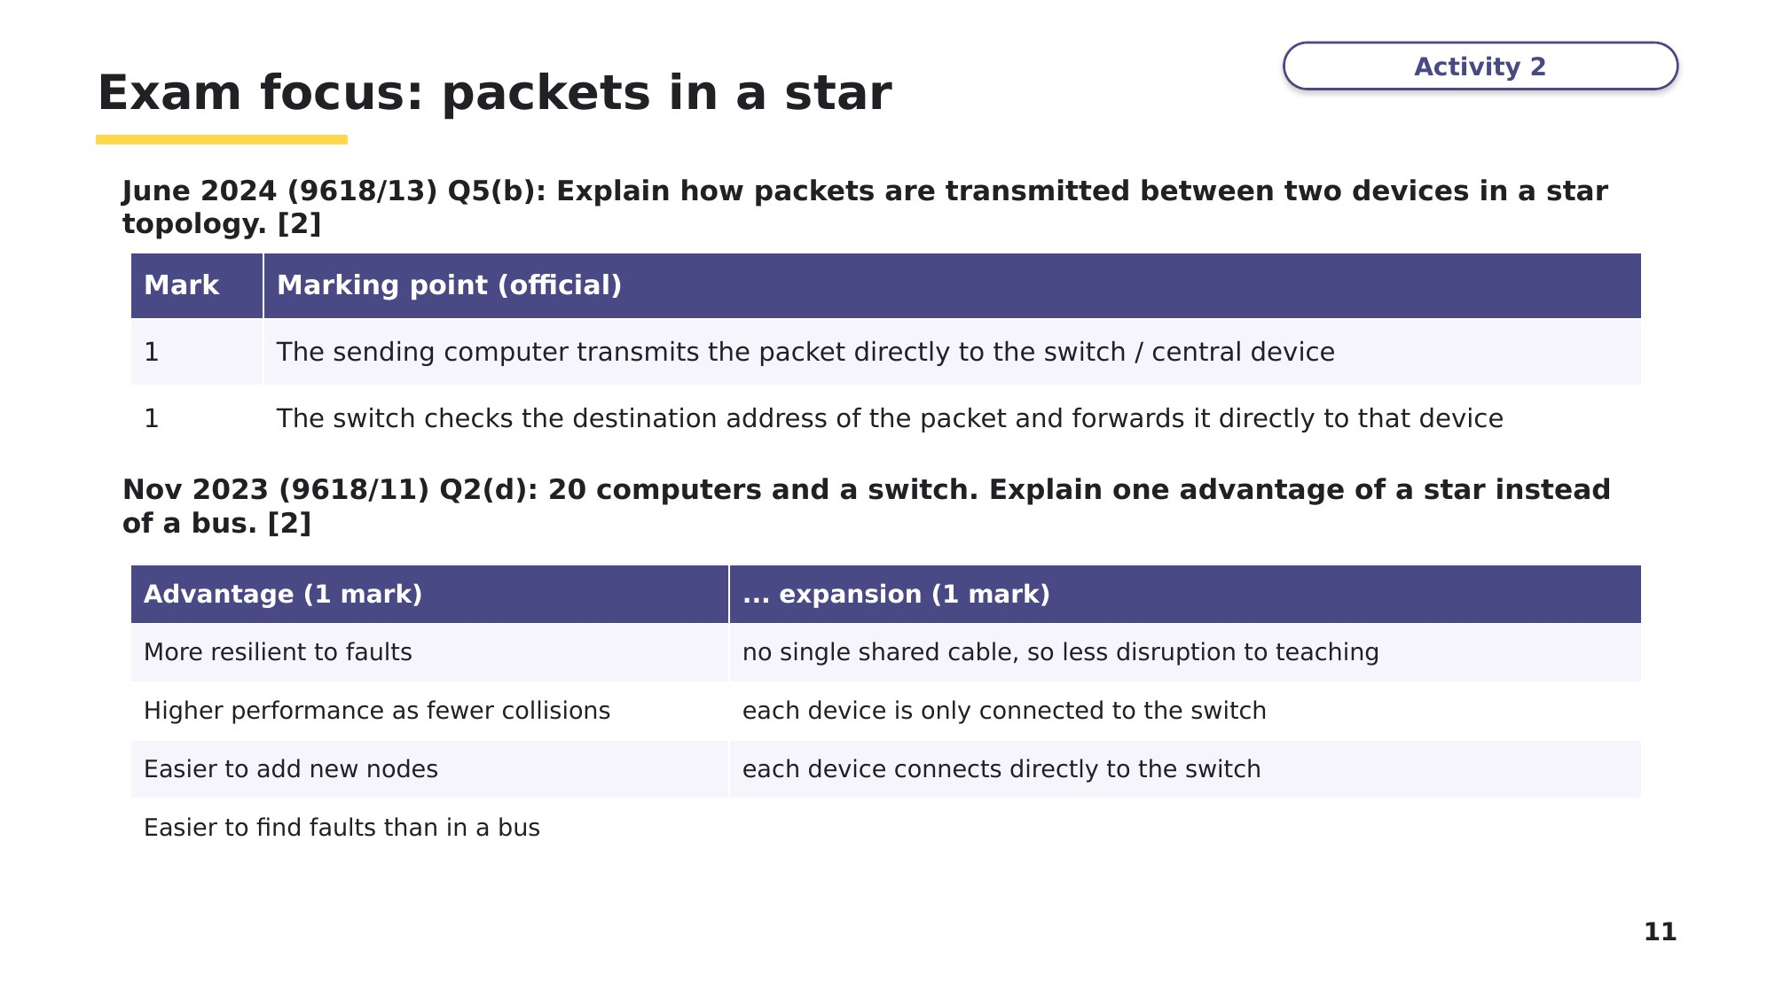
Slide 11 - Exam focus: packets in a star

Learn Cloud computing
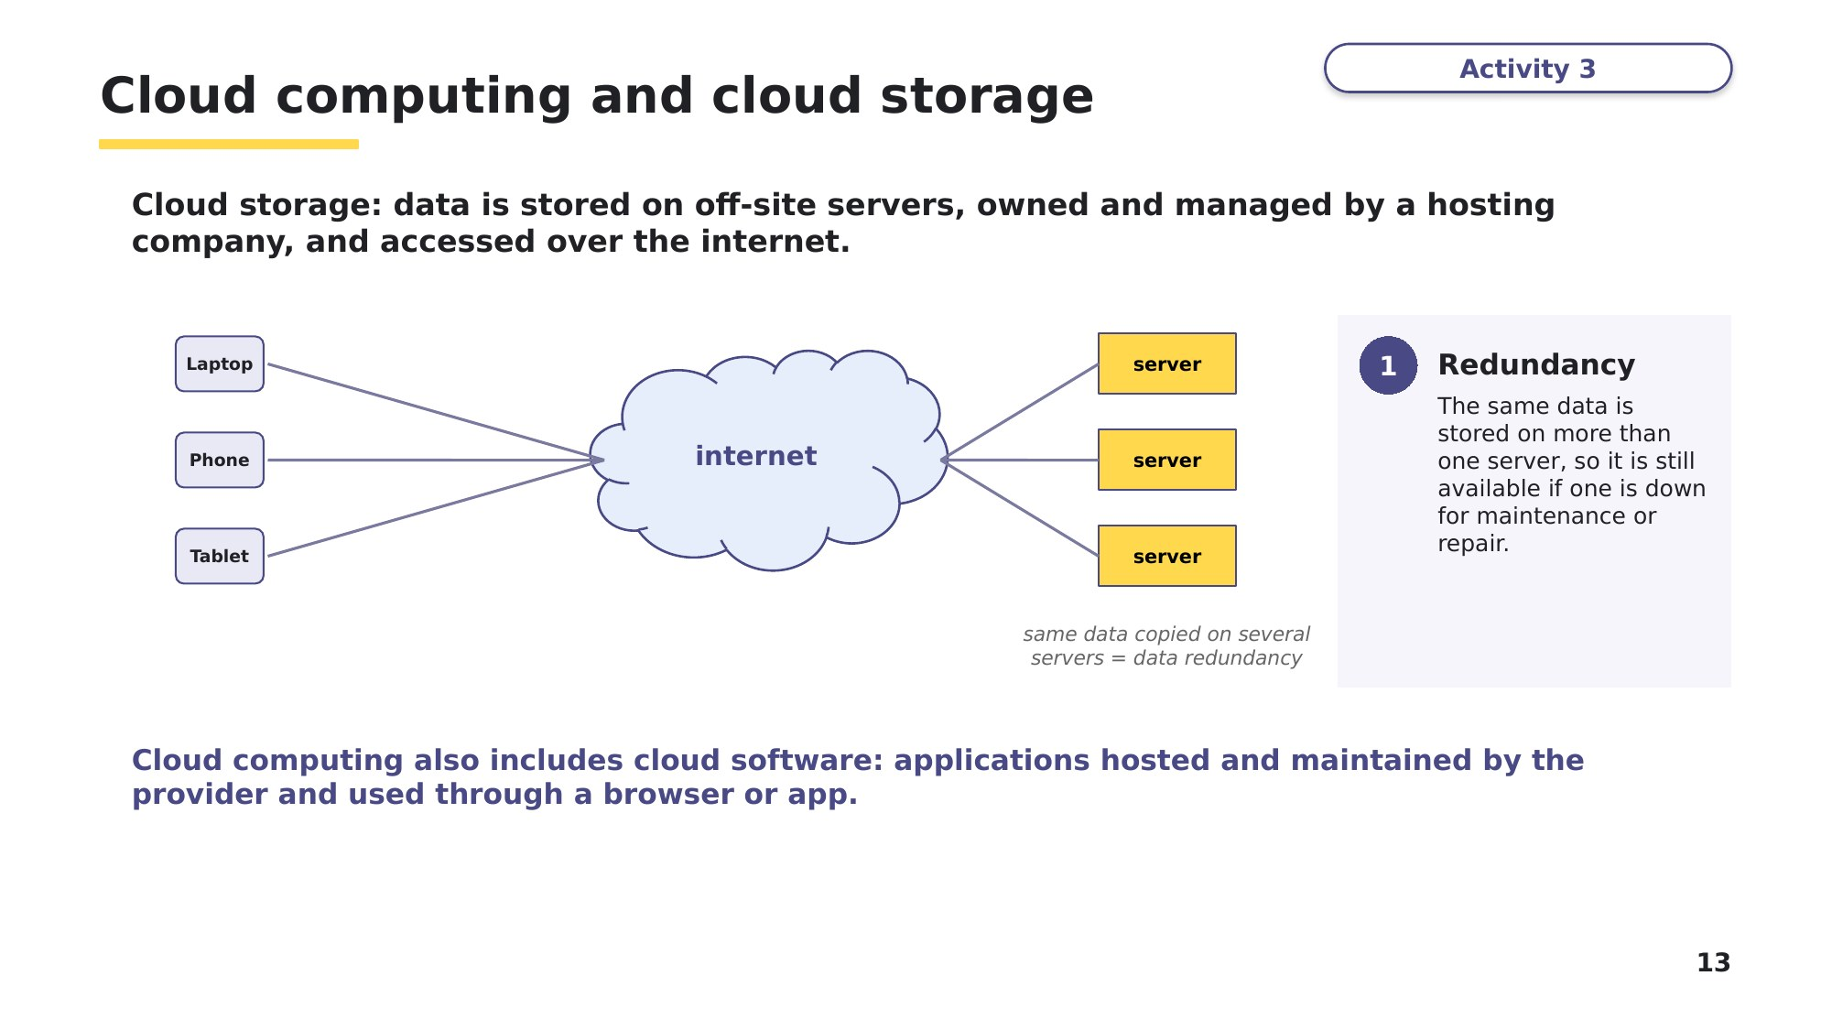
Slide 13 - Cloud computing and cloud storage
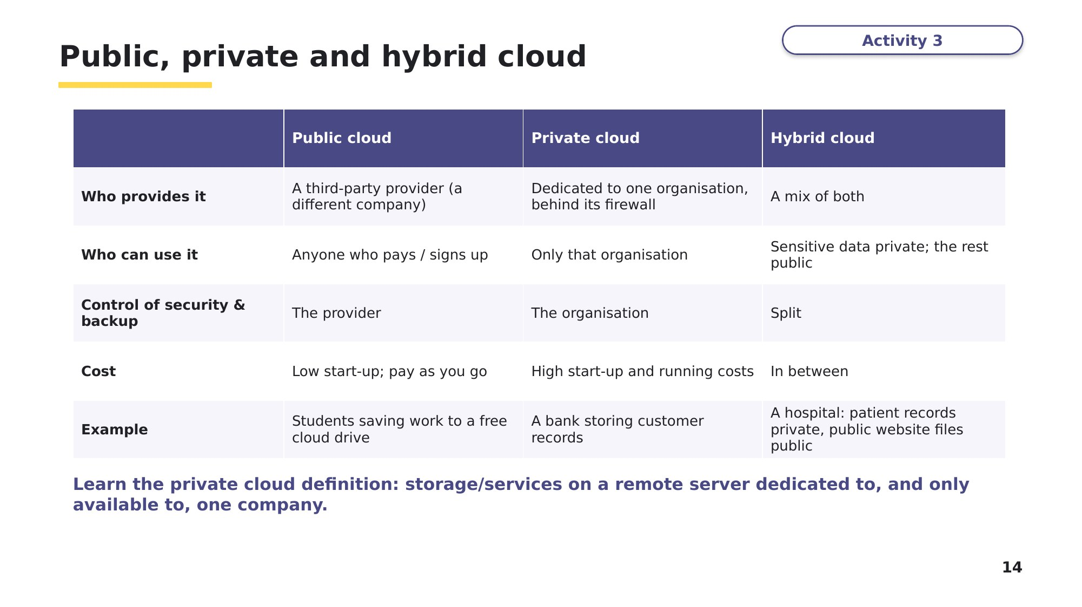
Slide 14 - Public, private and hybrid cloud
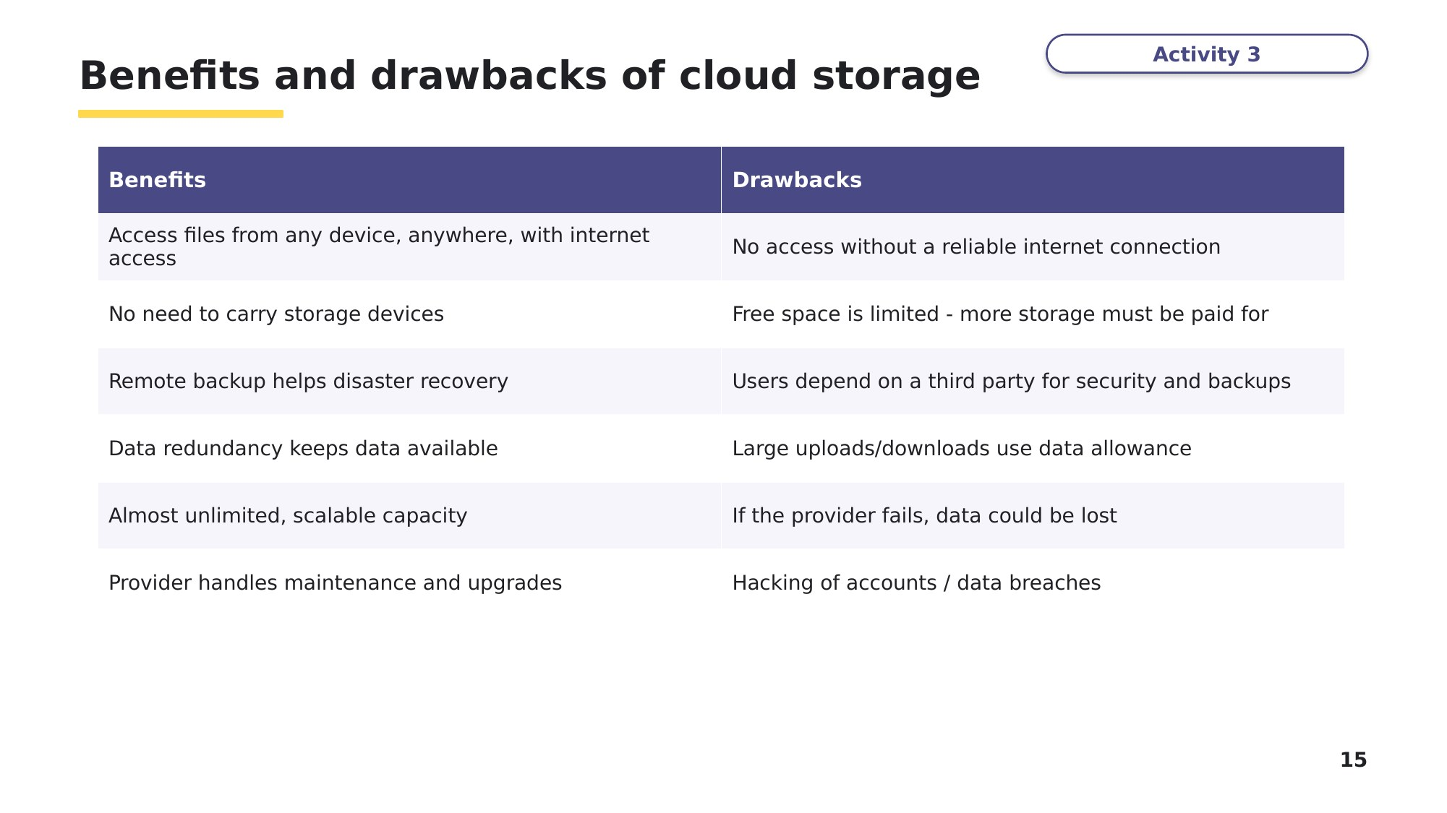
Slide 15 - Benefits and drawbacks of cloud storage
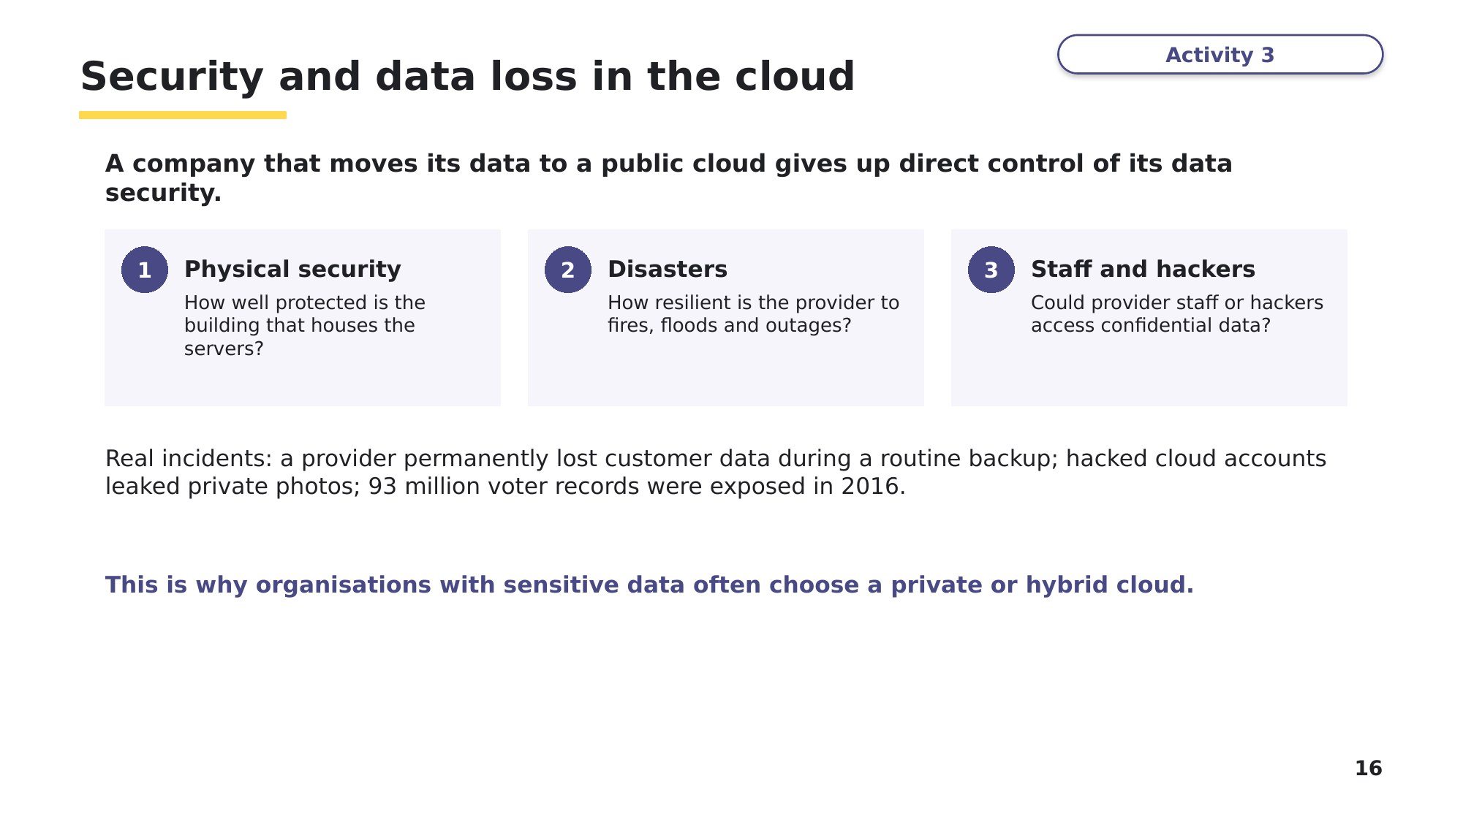
Slide 16 - Security and data loss in the cloud
Task 5 Exam questions: cloud computing [11 marks]
Parts (a) and (b) are from 9618/13 May/June 2024 Q5(a). Part (c) is from 9618/11 October/November 2023 Q2(c).
A company has private cloud storage for its employees to store their work.
(a) Define the term private cloud. [1]

(b) Describe the benefits to the company of using private cloud storage instead of public cloud storage. [3]

(c) Students at a school can save their files on a public cloud. Identify two drawbacks of the students storing their files on the public cloud. [2]

(d) Explain what is meant by data redundancy in cloud storage, and why providers use it. [2]

(e) Choose public, private or hybrid cloud for each organisation, and give a reason. [3]
Organisation | Cloud type | Reason
A small photography business storing copies of client photos
A national bank storing customer account records
A hospital with confidential patient records and a public appointment-booking website

Learn Check your Task 5 answers
Only look at this slide once you have finished Task 5. Mark (b) and (c) against the official marking points.
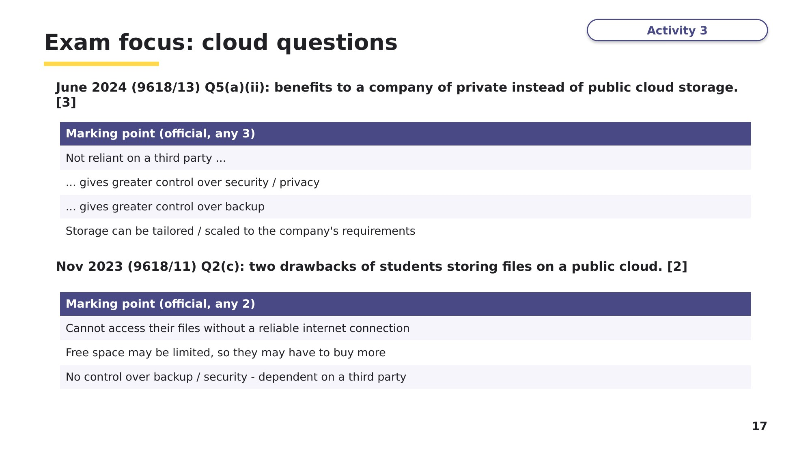
Slide 17 - Exam focus: cloud questions
Task 6 Extension
(a) The peer-to-peer network model and the mesh topology can look similar. Describe the differences between them. [4]
Textbook Extension Activity 2A.

(b) An office star network uses a hub as its central device. Explain why replacing the hub with a switch would make the network more secure and reduce collisions. [2]

Learn Review
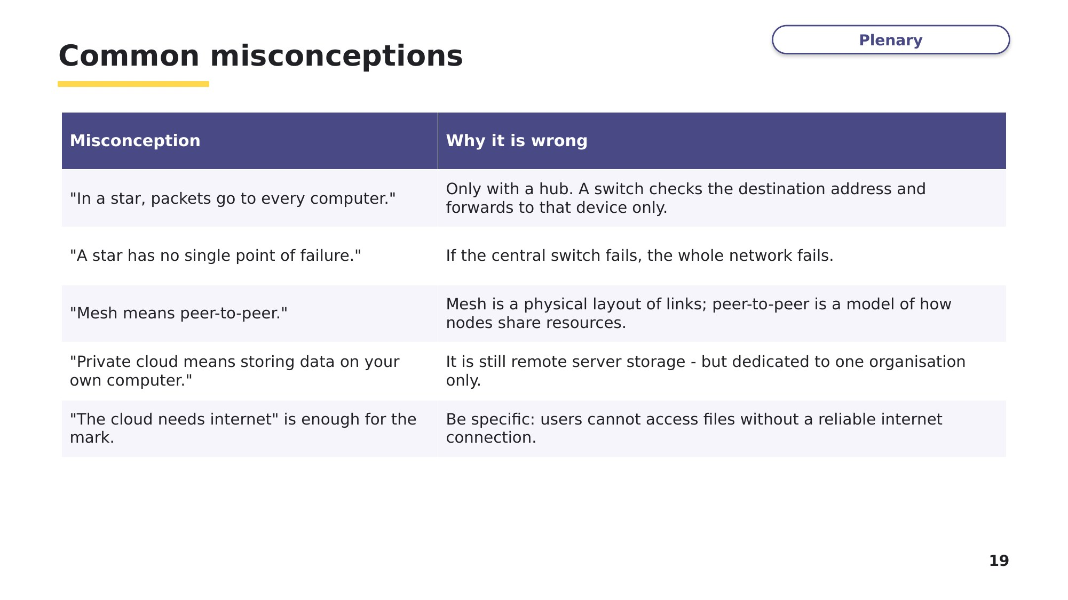
Slide 19 - Common misconceptions
Exit question
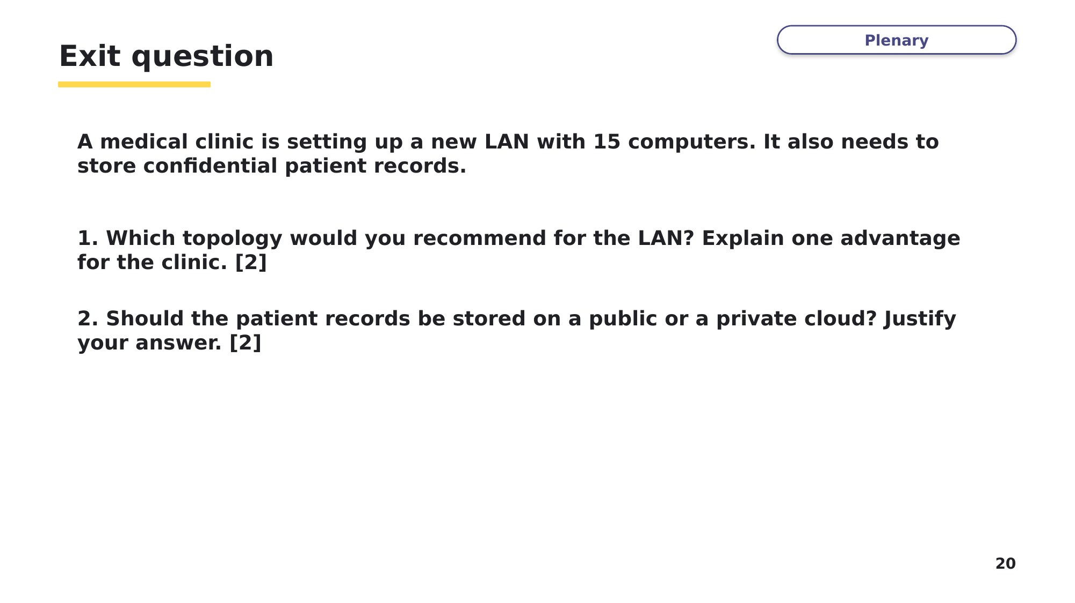
Slide 20 - Exit question

